Data Cloud Points to Remember :
when create a data stream behind the scene, a data source object as well as a DLO would be created.
Raw, unstructured data ingested from the source directly, not visible in the ui
It is essentially the configuration layer — not the data itself.
You cannot change the category(profile, engagement and other) once you have created a stream.
Profile : think of it like a noun ->user, device and contact information.
Engagement : data about interaction and activities (like what he did -> verb) there’s always a time factor for engagement category e.g: login, website visit, downloads, orders,
Other: used for unstructured data or data that doesn’t relate to individual or interactions e.g: products
Data Space : contains under which you the objects
DMO: used for identity resolution, segmentation, activation and other downstream processes.
> DSOs hold raw data, DLOs stage and structure data, and DMOs
provide a unified, harmonized view.
> Data flows from DSOs to DLOs to DMOs.
> DMOs are essential for data consumption and analysis within Data
Cloud.
Data Space = A separate section inside your single Data Cloud org, to keep data of different brands/regions/departments isolated from each other.
Example
Say you are a large company that owns 3 brands:
- Nike India
- Nike USA
- Nike Kids
All 3 use the same Data Cloud org (one instance) — but you don't want Nike India's customer data mixing with Nike USA's data.
we can manage access from permission set
if you don’t have access to that data space, you won’t be able to see anything inside of the data space.
When you create a Data Stream, you select the Data Space.
If you want to see the data use data explorer (the maximum no. of rows that can be displayed when viewing data in data explorer is 100.This number cannot be change) & column is 10
also use query editor (dll notation for data lake object, dlm for data model object) 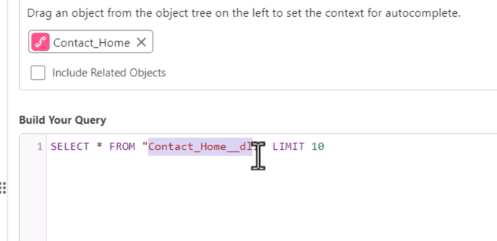
Identity Resolution in Data Cloud is the process of accurately identifying
and linking records that represent the same individual or account across
different data sources.
Why is Identity Resolution Important?
Inaccurate data : Duplicate records with conflicting information
Inefficient marketing: Sending the same marketing message multiple
times to the same person
Poor customer experience
Data Cloud employs a two-step process to resolve identities:
. Matching : This stage analyses records from different sources to identify
potential matches based on specific criteria.
. Reconciliation: Defining how to resolve conflicts when multiple
matching records are found for the same individual, such as selecting the
most recent or highest quality data source
unified DMO is going to hold unique records and then similarly a unified link DMO would also be created that is basically to tell okay this unique profile is coming from these two sources
Unified_DMO = "Who the customer is" — the final clean profile UnifiedLink_DMO = "Where they came from" — the breadcrumb trail back to source records
Consolidation rate measures how effectively your matching rules are bringing together fragmented customer data from different sources.
Consolidate rate = 1-(Number of unified profiles/Number of source profiles)*100
. Number of Unified Profiles: This is the count of unique customer profiles
created after the Identity Resolution process has linked the matching profiles
from different source systems
. Number of Source Profiles: This is the total count of individual customer
profiles present across all your source systems before the matching process
begins. 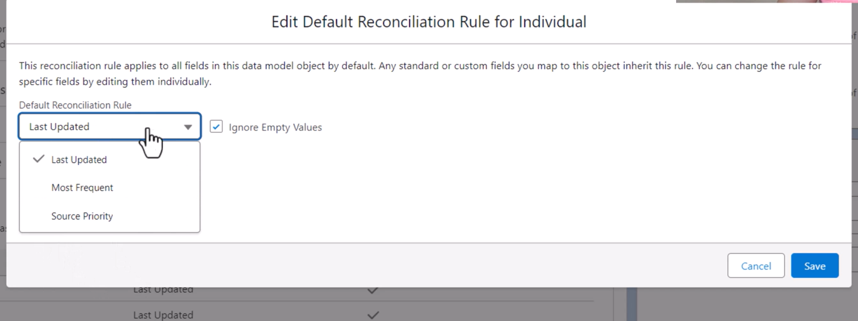
reconciliation rule based on receny, frequency & source system

Insights : are essentially calculations or analysis performed on your unified customer data to extract valuable information.
Type : calculated insights & streaming(real time data) insights
Calculated Insights are suitable for batch analysis and generating
metrics, while Streaming Insights excel at real-time analysis and
triggering immediate actions.
You can use insight for segmentation & Activation.
Use case for calculated insights
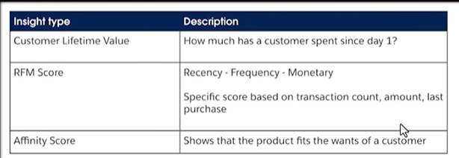
Segments : group of unified profiles and accounts that meet specific criteria.
A segment must be published before it can be used in an activation or reference in another segment
Streaming insights are not available for use in segmentation.
Once a segment is marked as inactive you cannot be re-enabled or used for activations although it can be copied to create a new segment.
Segments can be based on calculated insights.
Calculated Insights = COMPUTE new metrics and store them Segmentation = FILTER existing data to group people for activation
They are not alternatives — they work together in sequence.

